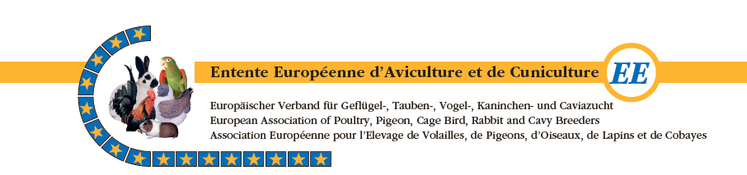
European Standard Commission for fancy Pigeons (ESCP)

Minutes of the ESCP Meeting on May 9, 2024, in Kecskemét (Hungary)

Welcome and Attendance
Chairman Jean-Louis Frindel welcomed the members present and guest candidate Jan Schrötz.
Secretary Georg Sattlecker and Philippe Hudry apologized for their absence. Jean-Louis warmly thanked them for their contributions to the commission as they are stepping down from their positions for professional reasons.

Minutes of the Last ESCP Meeting in 2023 in Sofia (Bulgaria)
These were attached to the invitation and were accepted by those present.

Reorganization of the ESCP
3a) Election of a New ESCP Chairman
Following the debate at the 2023 meeting, Lars Van Droogenbroeck submitted a written application and is ready to take on this role. In accordance with ESCP regulations, the members present unanimously elected Lars Van Droogenbroeck as chairman. The Pigeon Division must acknowledge and confirm this vote.

3b) Future Composition of the ESCP
Jan Schrötz (D-BDRG) introduced himself in detail in his written application and will be presented to the division assembly as a candidate.
Although Jean-Louis Frindel is stepping down as chairman, he will remain within the ESCP as an advisory member and contact person for the new chairman.
Gustl Heftberger will take on the role of secretary.
The other members are Istvan Rohringer, Ronald Bube, and Jan Schrötz (after his election).

Points for Discussion
4a) Regulations
European Championships for English Pouter and Pigmy Pouter: Complaints have been received from Croatia concerning the European Clubs for these breeds.

Gustl Heftberger informed about this matter and made it clear to the Croatian association that all nations are invited by the Czech federation and can participate, whether they are club members or not.

This championship is not conducted by any European breed club but by the Czech national federation.
For all exhibitions of EE member federations, it is important to invite only judges who are certified by their national judges' associations.

It is prohibited for unofficial judges or those from a federation excluded from the EE to participate in the juries of European exhibitions or European Championships for fancy pigeons.

4b) Ongoing Files for the European Standard:
Unfortunately, for various reasons, a ESCP Bulletin could not be published. Jean-Louis Frindel will update it by the EE judges' seminar in Suhl (Germany) in September 2024, and it will be published in German on the website.

Breed Originating from Turkey:
A request for recognition was submitted via Italy (Mrs. Mariangela Carboni) for this breed: "Sebap Pigeon" with particular characteristics. Since the Turkish pigeon federation is currently not a member of the EE, and a breed club cannot submit a request instead, this breed cannot be immediately included in the EE list of pigeon breeds (LERP).
There are two options: either via Italy or under the auspices of the ESCP. The second option, as an IdS, seems the most effective. Some corrections need to be made to the standard (including the description of the head and eyes). This breed must be presented once to the ESCP for review.

Breeds from Kosovo:
For the Kosovo Frill, the text needs to be corrected, and it will be reminded that nations must provide the standards in Word format so that the ESCP can directly correct the necessary passages.

The three new breeds submitted by Serbia, along with the corresponding standards (apart from a few minor details in the text), have been recognized:
Bachkotolpolski Highflyer
Exhibition Racing Homer of Batschka
Vojvodanski Highflyer
A request has been made to change the name of the "Sabac Highflyer" to "Belgrade Highflyer" on the EE breed list.

Breeds from Bulgaria Presented in Sofia in 2023:
The Kazanlak Highflyer is included in the LERP.
The Veliko Tarnovo and "Arap et Syr" breeds have been postponed due to inaccuracies in the current standard text.
National Breeds of Portugal / Standards:
These will be discussed in more detail with the Portuguese delegate in due course.

4c) Guide for Judging Fancy Pigeons: Guidelines to Avoid "Over-Typing":
This is an EE project. Germany and Austria have submitted proposals that are still being synthesized to be applied to EE nations for fancy pigeon exhibitions. These guidelines aim to support judgments within the framework of developing relevant breed characteristics and promoting animal welfare.
Gustl Heftberger has established a list of suitable exhibition cage dimensions for all breeds of pigeons in the LERP.
The synthesis results will be presented at the judges' training seminar in Suhl in September.

4d) Results of the WGH (Educational Small Animal - D):
In the context of tests in breeding short-beaked breeds, no results or messages have yet been communicated from the WGH.

5) International Judge Training:

5a) Serbia 2023 Report:
This judges' seminar brought together around fifty people. Unfortunately, the speakers and translators could not attend due to illness. The Serbian colleagues also organized a small exhibition for the SRB breeds, during which a technical discussion took place. Many thanks to our Serbian colleagues.

5b) 2024 Seminar:
This is organized by the division secretary Jürgen Weichold in Suhl (Germany). The conference venue and preliminary program have been prepared by Jürgen with CESP members. More detailed information will be available at the Pigeon Section meeting and published on the EE website.

5c) Forecasts:
At the request of the Spanish association, the seminar location should be exchanged with the organizer of Bosnia and Herzegovina (2025) with Spain (Majorca) in 2026. (This was approved by BIH at the division meeting.)

5d) As announced in point 5b, organizer BIH in 2026
5e) The 2027 judges' seminar will be organized by the CZ Association
5f) This seminar will be held in Romania in 2028.

6) Miscellaneous:
6a) It is urgent to update the EE website. Due to the creation of a new EE website, many documents and other data were lost during the transfer. The composition of the CESP needs to be updated. Jean-Louis has volunteered to provide the necessary data to Klaas Snijder (Birds NL Webmaster).

6b) The second Croatian association is not a member of the EE but uses rings with the EE logo and sells them to several nations. Unfortunately, the EE ring cannot be protected for cost reasons.

6c) Discussion on the EE or RBES regarding the different management of regulations or restrictions in various countries or within the EU.
New information presented at the division meeting: For collective transport to exhibitions in another country, only one Traces certificate is required. The sale of animals at exhibitions is also possible again. Cross-border traffic in third countries remains very problematic.

6d) Ronald Bube presents comments on various subjects.
An adjustment of the proportions of the Czech Satin Pouter from 3/5 instead of 2/3, as well as an adjustment of the stance to be more upright than the current 30 degrees in the current image. The matter will be handled by Jean-Louis Frindel.
There is a problem with the leg position of the King in various publications (club bulletins, especially German, and various magazines). In the King standard and its update, an upright position has always been required! The BZA-D plans to study a different formulation in cooperation with the German Club, which should then be agreed upon with the CESP and applicable to all EE countries. The standard drawing shows straight legs (stretched and straight are not the same criteria!), but the subjects concerned show that they are inverted at the heel. This must be taken into account everywhere and commented on precisely. This applies to all of Europe.

6e) Jean-Louis Frindel asks the German colleagues present for clarification regarding the shield mark of the Old German Frill to check if the French translation of the German standard is correct: "the thumb feathers and secondary feathers are desired to be colored." The French translation is correct. This means that if this coloration is not complete (due to the allowed 7 to 11 white flights), it should neither be considered a wish nor a fault.
Chairman Jean-Louis Frindel closes the session at 5:00 PM.
August Heftberger - Secretary

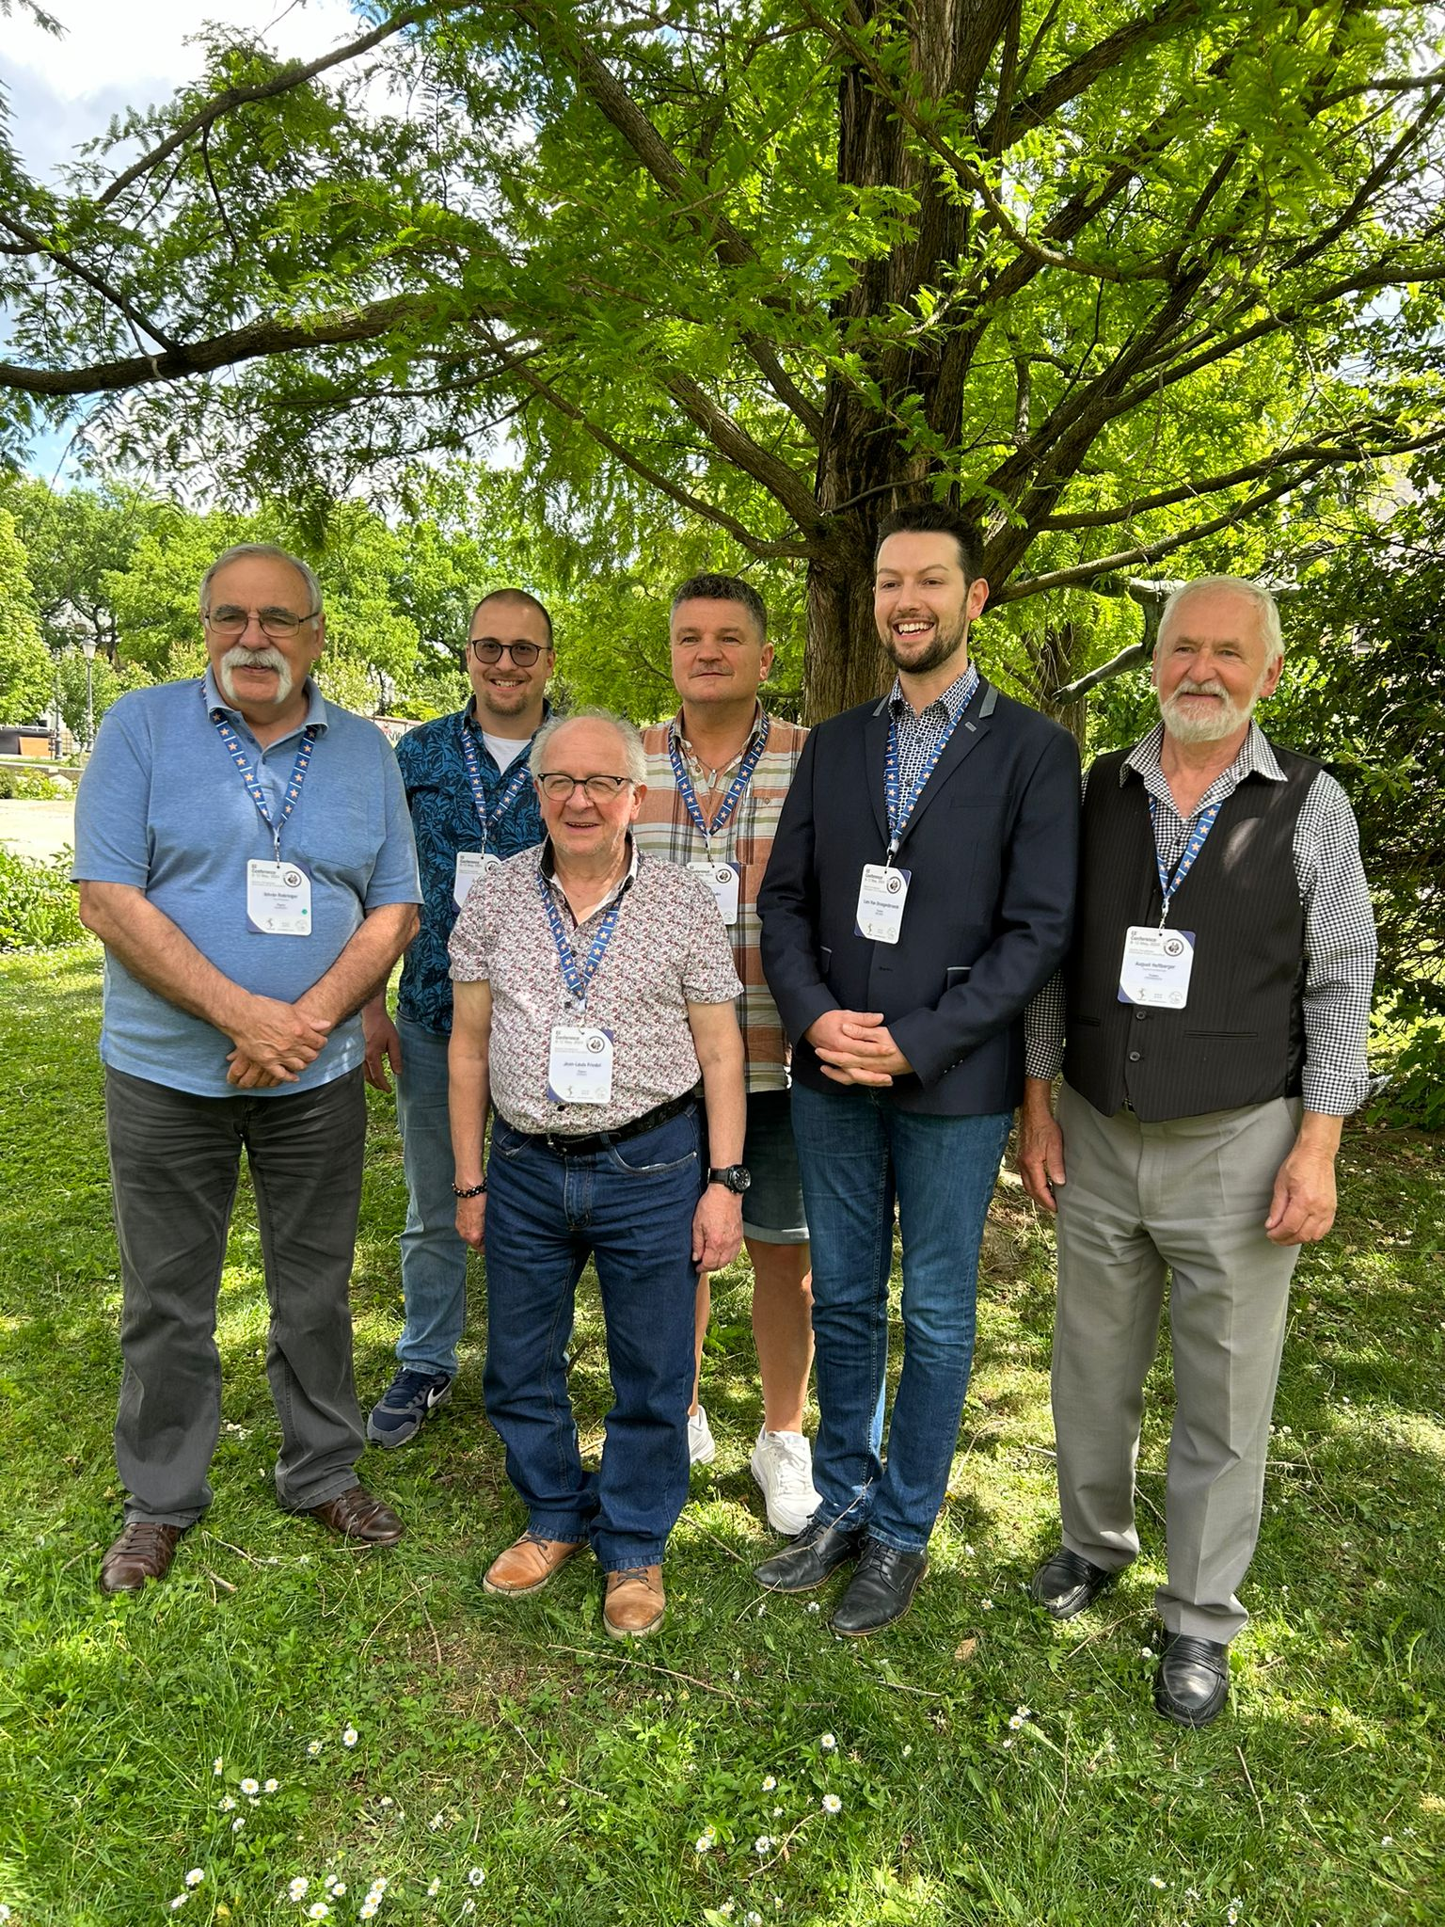

The former and new members of the ESCP:
(from left to right)
Istvan Rohringer, Jan Schrötz, Jean-Louis Frindel, Ronald Bube,
Chairman Lars Van Droogenbroek, and Secretary August Heftberger

